Partial / residual correlation: NZDUSD and EURGBP
Method 07 / daily log returns / leave-currency-out USD factor / Alpari D1 full available history

Study setup
Logical pair: NZDUSD , EURGBP
Broker symbols: NZDUSD_i , EURGBP_i
Snapshot: 2026-11-03_majors_alpari_D1
Timeframe: D1
Matched return window: 1999-01-06 to 2026-11-02 (UTC bar dates)
Matched return count n: 7129
Dropped unfinished last bar dated 2026-11-03 UTC after a tick-volume check against the prior complete day.
USD-strength sign rule: minus log return when USD is the quote (EURUSD, GBPUSD, AUDUSD, NZDUSD); plus log return when USD is the base (USDJPY, USDCHF, USDCAD). EURGBP is never a constituent.
Control z constituents (4): AUDUSD, USDJPY, USDCHF, USDCAD
z_t = equal-weight mean of those USD-strength returns on the same day
Complete matched rows (Excel): NZDUSD-EURGBP_Partial_D1.xlsx
Complete matched rows (HTML table): NZDUSD-EURGBP_Partial_D1_data.html

Method carried forward
Partial / residual correlation regresses each matched daily log return of close, ln(close_t / close_t-1), on the same leave-currency-out USD strength factor z, then takes Pearson correlation of the two residual series. Quotes are not inverted. z is the equal-weight mean of USD-strength returns from other majors that do not share a non-USD currency with either leg; EURGBP is never a constituent. USD-strength is minus the log return when USD is the quote (EURUSD, GBPUSD, AUDUSD, NZDUSD) and plus the log return when USD is the base (USDJPY, USDCHF, USDCAD). OLS uses an intercept on each leg. rho_partial is symmetric under swap of the two symbols. It describes leftover linear co-movement after removing linear z; it is not a cause, not a lead, and not a trading signal. Daily rows are not independent and residuals are estimated, so the two-sided p-value and Fisher interval are secondary. Same-sample raw Pearson r is a side check only.

Regression on z
leg | intercept_a_or_c | slope_b_or_d | R2
NZDUSD | 6.26e-06 | -1.2275552 | 0.51095437
EURGBP | 2.114e-05 | -0.20269906 | 0.03430148

Results
rho_partial: -0.140236
Two-sided p-value: 1.22198e-32
Approximate 95% Fisher interval: [-0.162919, -0.117404]
Same-sample raw Pearson r: 0.036015
rho_partial minus r: -0.176251

Conclusion
Over 7129 matched daily rows for NZDUSD and EURGBP after removing a leave-currency-out USD factor built from 4 constituents, rho_partial is -0.1402 (negative, weak residual linear link in this sample). Approximate 95% Fisher interval: [-0.1629, -0.1174]. Same-sample raw Pearson r is 0.0360 (partial minus r = -0.1763). Leg R-squared on z: NZDUSD=0.5110, EURGBP=0.0343. Two-sided p under the usual independent-pairs model is 1.222e-32; residuals are estimated and daily FX rows are linked, so treat p as secondary. This does not establish cause, lead-lag, or a lasting trading rule.

Charts
Daily closes
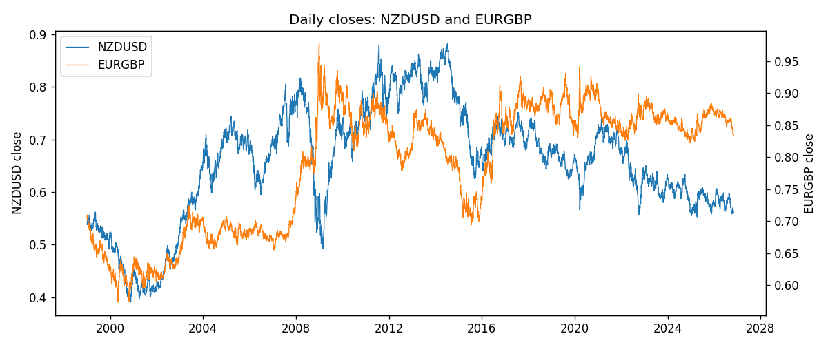
Log returns and control z
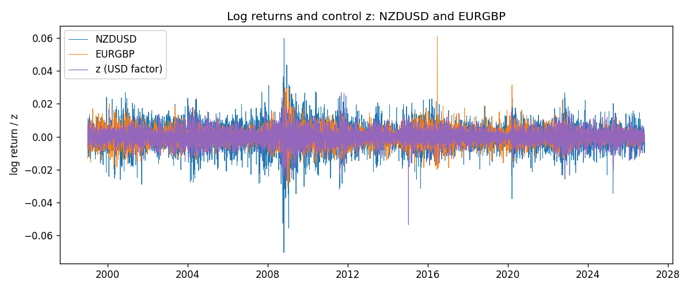
Residual scatter e_x vs e_y
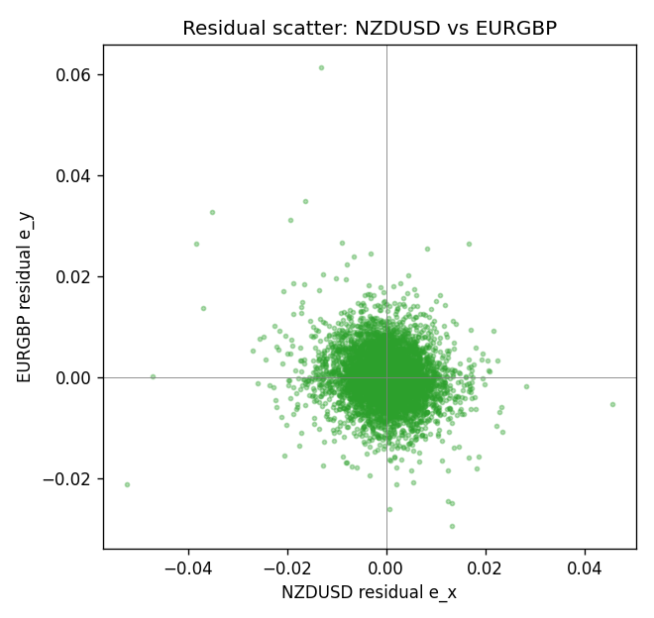

Data report
Every matched row that entered the partial correlation is stored in the sibling Excel workbook named NZDUSD-EURGBP_Partial_D1.xlsx. That file is the complete data archive for redrawing charts. Embedding all rows as a Word table is impractical at this length; the Word file holds the column list, column summaries, and the first and last 15 matched rows.
Columns: time, NZDUSD_open, EURGBP_open, NZDUSD_high, EURGBP_high, NZDUSD_low, EURGBP_low, NZDUSD_close, EURGBP_close, NZDUSD_tick_volume, EURGBP_tick_volume, NZDUSD_spread, EURGBP_spread, NZDUSD_real_volume, EURGBP_real_volume, NZDUSD_log_return, EURGBP_log_return, usd_strength_AUDUSD, usd_strength_USDJPY, usd_strength_USDCHF, usd_strength_USDCAD, z, NZDUSD_fitted, EURGBP_fitted, NZDUSD_resid, EURGBP_resid
Column summaries (matched calculation rows)
column | count | mean | std | min | 25% | 50% | 75% | max
NZDUSD_open | 7129 | 0.65708048 | 0.10790819 | 0.3913 | 0.59228 | 0.66889 | 0.72513 | 0.88218
EURGBP_open | 7129 | 0.78787915 | 0.09637748 | 0.5734 | 0.6884 | 0.83444 | 0.8655 | 0.9769
NZDUSD_high | 7129 | 0.66100615 | 0.1083964 | 0.3961 | 0.59564 | 0.6726 | 0.72961 | 0.88421
EURGBP_high | 7129 | 0.79096121 | 0.09675282 | 0.5789 | 0.6905 | 0.83739 | 0.86841 | 0.9799
NZDUSD_low | 7129 | 0.65339495 | 0.10750223 | 0.3897 | 0.58862 | 0.6651 | 0.72131 | 0.87988
EURGBP_low | 7129 | 0.78517685 | 0.09619509 | 0.5682 | 0.6863 | 0.83221 | 0.86303 | 0.9661
NZDUSD_close | 7129 | 0.65716294 | 0.10790216 | 0.3907 | 0.5923 | 0.66906 | 0.7253 | 0.8822
EURGBP_close | 7129 | 0.78792406 | 0.09637588 | 0.5735 | 0.6884 | 0.83444 | 0.86555 | 0.977
NZDUSD_tick_volume | 7129 | 69226.059 | 123488.53 | 17 | 5823 | 34196 | 58697 | 1127682
EURGBP_tick_volume | 7129 | 87747.814 | 145877.32 | 332 | 6718 | 44856 | 82002 | 1424684
NZDUSD_spread | 7129 | 30.026371 | 25.537788 | 0 | 9 | 17 | 40 | 80
EURGBP_spread | 7129 | 21.135222 | 19.050893 | 0 | 4 | 13 | 40 | 50
NZDUSD_real_volume | 7129 | 1.6829995e+10 | 8.5303932e+10 | 0 | 0 | 0 | 0 | 2.705649e+12
EURGBP_real_volume | 7129 | 2.8078235e+10 | 1.3570431e+11 | 0 | 0 | 0 | 0 | 3.5726265e+12
NZDUSD_log_return | 7129 | 2.603e-05 | 0.00764647 | -0.07027433 | -0.00423176 | 0.00024088 | 0.0045915 | 0.05966839
EURGBP_log_return | 7129 | 2.44e-05 | 0.00487311 | -0.03067367 | -0.00262262 | -9.978e-05 | 0.00256826 | 0.06075387
usd_strength_AUDUSD | 7129 | -3.429e-05 | 0.00755471 | -0.0806166 | -0.004155 | -0.00029309 | 0.00384986 | 0.08602525
usd_strength_USDJPY | 7129 | 5.124e-05 | 0.0062132 | -0.03908203 | -0.00320044 | 0.00012446 | 0.00340927 | 0.05184024
usd_strength_USDCHF | 7129 | -7.228e-05 | 0.00659123 | -0.19545699 | -0.00334859 | 7.816e-05 | 0.00331593 | 0.09051364
usd_strength_USDCAD | 7129 | -9.1e-06 | 0.00514798 | -0.03859748 | -0.00283484 | 5.567e-05 | 0.00272835 | 0.03436319
z | 7129 | -1.611e-05 | 0.00445257 | -0.0534387 | -0.00258359 | 3.75e-05 | 0.00251736 | 0.02728206
NZDUSD_fitted | 7129 | 2.603e-05 | 0.00546578 | -0.03348397 | -0.00308394 | -3.977e-05 | 0.00317775 | 0.06560521
EURGBP_fitted | 7129 | 2.44e-05 | 0.00090253 | -0.00550891 | -0.00048913 | 1.354e-05 | 0.00054483 | 0.01085311
NZDUSD_resid | 7129 | 0 | 0.00534732 | -0.05225081 | -0.00275884 | 0.00015624 | 0.00293284 | 0.04555695
EURGBP_resid | 7129 | 0 | 0.00478881 | -0.02934029 | -0.00264466 | -0.00014562 | 0.00253132 | 0.06133712
First 15 matched rows (selected columns)
time | NZDUSD_close | EURGBP_close | NZDUSD_log_return | EURGBP_log_return | z | NZDUSD_fitted | EURGBP_fitted | NZDUSD_resid | EURGBP_resid
1999-01-06 | 0.5383 | 0.7019 | 0.0020455609 | -0.013303338 | 0.0022511601 | -0.0027571667 | -0.00043517067 | 0.0048027277 | -0.012868167
1999-01-07 | 0.5417 | 0.7097 | 0.0062963171 | 0.011051402 | -0.0073961958 | 0.0090854948 | 0.0015203393 | -0.0027891777 | 0.0095310625
1999-01-08 | 0.5414 | 0.7062 | -0.00055396548 | -0.004943862 | 0.00097589992 | -0.0011917145 | -0.00017667663 | 0.00063774902 | -0.0047671854
1999-01-11 | 0.547 | 0.7053 | 0.010290425 | -0.0012752393 | -0.0054085655 | 0.0066455689 | 0.0011174485 | 0.0036448563 | -0.0023926878
1999-01-12 | 0.5441 | 0.7077 | -0.0053157489 | 0.0033970309 | 0.0084907811 | -0.010416646 | -0.001699936 | 0.0051008968 | 0.0050969669
1999-01-13 | 0.5387 | 0.708 | -0.0099742238 | 0.00042381861 | 0.00057746195 | -0.00070260991 | -9.5913624e-05 | -0.0092716139 | 0.00051973224
1999-01-14 | 0.5386 | 0.7066 | -0.00018564931 | -0.0019793588 | 0.0018022254 | -0.0022060746 | -0.00034417202 | 0.0020204253 | -0.0016351867
1999-01-15 | 0.5382 | 0.7012 | -0.00074294208 | -0.0076715819 | 0.002665738 | -0.003266084 | -0.00051920522 | 0.0025231419 | -0.0071523767
1999-01-18 | 0.5372 | 0.7017 | -0.0018597736 | 0.00071280921 | -0.00076512937 | 0.00094549499 | 0.00017622837 | -0.0028052686 | 0.00053658084
1999-01-19 | 0.5382 | 0.7007 | 0.0018597736 | -0.0014261269 | -0.0025421154 | 0.0031268434 | 0.00053642177 | -0.0012670697 | -0.0019625487
1999-01-20 | 0.5404 | 0.7021 | 0.0040793678 | 0.0019960086 | -0.0013443687 | 0.0016565433 | 0.00029363965 | 0.0024228245 | 0.001702369
1999-01-21 | 0.5426 | 0.7016 | 0.0040627941 | -0.00071240297 | -0.00010504696 | 0.00013520743 | 4.2430291e-05 | 0.0039275867 | -0.00075483326
1999-01-22 | 0.5361 | 0.7004 | -0.012051689 | -0.0017118406 | 0.005163803 | -0.0063325965 | -0.0010255606 | -0.0057190929 | -0.00068628001
1999-01-25 | 0.5342 | 0.6966 | -0.0035504102 | -0.0054402425 | -2.2443468e-05 | 3.3807079e-05 | 2.568664e-05 | -0.0035842172 | -0.0054659291
1999-01-26 | 0.5381 | 0.6962 | 0.0072741158 | -0.00057438255 | 0.00076019006 | -0.00092691875 | -0.00013295244 | 0.0082010346 | -0.00044143011
Last 15 matched rows (selected columns)
time | NZDUSD_close | EURGBP_close | NZDUSD_log_return | EURGBP_log_return | z | NZDUSD_fitted | EURGBP_fitted | NZDUSD_resid | EURGBP_resid
2026-10-13 | 0.56127 | 0.84458 | 0.0047326165 | 0.00020130374 | -0.0031322953 | 0.0038513217 | 0.00065605068 | 0.00088129478 | -0.00045474694
2026-10-14 | 0.55918 | 0.84553 | -0.0037306483 | 0.0011241873 | 0.0015131073 | -0.0018511662 | -0.00028556806 | -0.0018794821 | 0.0014097554
2026-10-15 | 0.56185 | 0.84479 | 0.0047634855 | -0.00087557391 | -0.0019258521 | 0.0023703461 | 0.00041150578 | 0.0023931393 | -0.0012870797
2026-10-16 | 0.56509 | 0.84307 | 0.0057501001 | -0.0020380844 | -0.0027064228 | 0.0033285398 | 0.00056972674 | 0.0024215603 | -0.0026078112
2026-10-19 | 0.56616 | 0.84259 | 0.0018917133 | -0.00056950988 | 4.0082583e-05 | -4.2947098e-05 | 1.3012668e-05 | 0.0019346604 | -0.00058252255
2026-10-20 | 0.56827 | 0.83957 | 0.0037199341 | -0.0035906254 | -0.0030128575 | 0.0037047053 | 0.00063184076 | 1.5228823e-05 | -0.0042224662
2026-10-21 | 0.57003 | 0.83839 | 0.0030923331 | -0.00140647 | -0.0012956664 | 0.0015967584 | 0.00028376772 | 0.0014955747 | -0.0016902377
2026-10-22 | 0.56815 | 0.83682 | -0.0033035227 | -0.0018743924 | -0.003690344 | 0.0045363573 | 0.00076916663 | -0.00783988 | -0.002643559
2026-10-23 | 0.56991 | 0.83751 | 0.0030929853 | 0.00082421033 | 0.00091382683 | -0.0011155164 | -0.00016409447 | 0.0042085016 | 0.0009883048
2026-10-26 | 0.56826 | 0.83762 | -0.0028993932 | 0.00013133309 | 0.002306265 | -0.002824811 | -0.00044634038 | -7.4582122e-05 | 0.00057767347
2026-10-27 | 0.56811 | 0.83595 | -0.00026399852 | -0.0019957343 | 0.0015615441 | -0.0019106251 | -0.00029538616 | 0.0016466265 | -0.0017003482
2026-10-28 | 0.56261 | 0.83651 | -0.0097283914 | 0.00066967224 | -0.002475122 | 0.0030446053 | 0.00052284227 | -0.012772997 | 0.00014682997
2026-10-29 | 0.56296 | 0.83553 | 0.00062190714 | -0.0011722209 | -0.00031781628 | 0.0003963935 | 8.5558432e-05 | 0.00022551364 | -0.0012577793
2026-10-30 | 0.56307 | 0.83351 | 0.00019537668 | -0.0024205543 | -0.00059595344 | 0.0007378222 | 0.00014193657 | -0.00054244552 | -0.0025624909
2026-11-02 | 0.56161 | 0.83426 | -0.0025962955 | 0.00089940465 | 0.00025789175 | -0.00031031986 | -3.1137045e-05 | -0.0022859757 | 0.0009305417

